**A pilot and proof of concept study for using cue scaffolding and perceptual learning in VR to stereovision**

Angelica Godinez1, Santiago M González2, Dennis M Levi1

1School of Optometry, University of California, Berkeley

2Construcción e Ingeniería de Fabricación, Universidad de Oviedo

Acknowledgements: This research was supported by The UC Berkeley, Chancellor and Regents Graduate Fellowship (AG), NIH training grant T32EY007043-40 (AG), UC Berkeley’s URAP stipend (ALK), grant R01EY020976 (DML) from the National Eye Institute and received mobility aid from the Universidad de Oviedo (SMG).

**ABSTRACT**

**Background:**

**Methods:**

**Results:**

**Discussion:**

**INTRODUCTION**

[Begin with the notion that we have a very rich sense of 3D in the world. That sense arises from a multitude of different visuals cues. Only some of these cues require stereopsis (depth from binocular disparity).]

Depth perception is a complex process where the brain integrates different visual cues (Swanston & Wade, 2001) Most of them require only one eye (monocular cues) and are categorized as psychological: overlapping (interposition), perspective (conical projection), lighting-shading, chromatic attenuation and focus are the most relevant. Accommodation is categorized as a physiological monocular cue. On the other hand, the binocular cues, convergence and retinal disparity, require both eyes. Retinal disparity or stereopsis arises from the concept of parallax: each eye perceives a slightly different image of the world that the brain must integrate in a single cyclopean perception (Wheatstone, 1838). Parallax is in the origin of a similar cue available to monocular vision, motion parallax, created by the relative motion between the user’s head and the perceived scene.

[Then introduce the idea of scaffolding]

Humans employ a statistically optimal strategy for combining depth cues within vision (Knill & Sanders, 2003; Hillis et al., 2004) and across different modalities (Ernst & Banks, 2002, van Beers et al., 2011). When sensory noise and cue conflict is relatively low, the optimal model is a linear weighted average of each cue, which aims at reducing variance (Ernst & Banks, 2002; Knilll & Sanders, 2003; Hillis et al., 2004). However, optimal integration seems to be adaptable and can be influenced through feedback (Jacobs & Fine, 1999; Ernst et al., 2000; Atkins et al., 2001), though feedback is not a requirement (Knill, 2007b). This reweighting of context-specific priors seems to be highly adaptable (Jacobson & Fine, 1999; Knill, 2007a; Knill, 2007b) and can occur at a relatively fast rate (vanBeers et al., 2011). Importantly, by pairing haptic feedback with binocular cues, observers can be trained to rely on binocular disparity cues (Ernst et al., 2000; Knill, 2007b; Vedamurthy et al., 2016).

[Then - why is stereopsis important?]

Stereopsis plays a key role in extracting depth information from natural scenes with binocular thresholds being a factor of 10 better than monocular thresholds (McKee & Taylor, 2010). In addition to the perceptual benefits, stereopsis also plays an important role in planning and executing everyday visuomotor tasks such as reaching and grasping (Meltmoth & Grant, 2006; Melmoth et at., 2009). However, abnormal visual experience during the “sensitive period” of development may result in amblyopia and, as a result, in reduced or absent stereopsis (Held et al., 1980; Petrig et al., 1981; Held, 1991; Birch & Petrig, 1996; Banks et al., 1975). Amblyopia, the leading cause of visual loss in children, is a neuro-developmental disorder that arises from an imbalance between the ocular inputs to the visual pathway (Hess et al., 2010; Li, Dumoulin, Mansouri, & Hess, 2007). It is characterized as reduced visual acuity in an otherwise normal eye despite best optical correction (Holmes & Clarke, 2006) and is typically secondary to misalignment of the visual axis (strabismus) and/or unequal refractive error (anisometropia). However, categorization of amblyopia based on etiology may be too restrictive (Maurer & McKee, 2016) since amblyopic deficit interactions are complex.

People who are stereo-blind or -anomalous exhibit deficits in depth perception, measurable for example in precision grasping (Grant et al., 2007; Melmoth et al., 2009), and particularly in the kinematic aspects that rely on visual feedback and online corrections (Meltmoth & Grant, 2006; Melmoth et at., 2009). Thus, for the overall well-being of people with amblyopia, stereopsis may be an important function to recover/ strengthen. Perceptual Learning, PL, defined as “any relatively permanent and consistent change in the perception of a stimulus array following practice or experience with this array (…)” [Gibson, 1963], has demonstrated great potential in amblyopia treatment (Levi & Li, 2009). Although functionally suppressed when viewing binocularly (Tavers, 1938; Birch, 2013), binocular stereovision mechanisms seem to be intact in people with amblyopia (Birch & Stager, 1985; Baker et al., 2007; Ding & Levi, 2014; Hess et al., 2014; Giaschi et al., 2013). Different visual stimuli have been evaluated to recover specifically stereoacuity when affected by amblyopia, from monocular training (Li et al., 2011) to dichoptic training (Vedamurthy et al., 2015) and direct training (Ding & Levi, 2011; Portela-Camino et al., 2018). Interestingly, individuals with strabismic amblyopia have a very low probability of improvement with monocular training; however, they fare better with dichoptic training than monocular training, and even better with direct training (Levi et al., 2015). People with normal binocular vision can also benefit from training, improving their stereoacuity thresholds (Schoemann, 2017). Moreover, training on demanding stereovision tasks improve stereoacuity in observers with normal vision even under natural (as opposite to laboratory) conditions (Chopin, Levi & Bavelier, 2017).

Considering that the main drawbacks of most laboratory-based training paradigms are user compliance, attention and motivation, several authors have proposed the use of specifically designed video games to treat amblyopia both in the clinic and as a home-based therapy strategy. Gamification, i.e. the use of game principles in non-game contexts, includes the use of levels of increasing difficulty adapted to participant performance, rewards, a story line, and social context, among other aspects [references]. The relatively new widespread use of cloud storage allows remote tracking of user compliance and incoming data, addressing the importance of practitioner supervision (Holmes, 2016). The ease of data monitoring has made remote therapy a viable and convenient option. Several studies, including clinical trials (Gao et al., 2018), have reported benefits of using video games to treat amblyopia (Li et al., 2009; Li et al., 2011; Vedamurthy et al., 2015a; Vedamurthy et al., 2015b). Suppression, a hindrance to binocular function in amblyopia (Hess et al., 2010; Hess et al., 2014), seems to be responsive to video game play (Foss, 2017) and direct stimulation of stereopsis has been tested using this approach (Portela-Camino et al., 2018).

[references serious games and gamification]

* The Gamification of Learning and Instruction. Game-based methods and strategies for training and education. Karl M. Kapp. John Wiley & Sons, 2012
* Serious Games. Games that educate, train, and inform. David Michael, Sande Chen. Thomson Course Technology, 2006
* Developing Serious Games. Bryan Bergeron. Charles River Media, 2006

Recent commercialization of Virtual Reality head-mounted displays (VR-HMDs) have opened the opportunity to design therapies that incorporate gamification principles and build upon successful laboratory-based techniques such as PL and dichoptic training. VR-HMDs provide researchers and clinicians with the ability to present separate images to each eye, correct through software any misalignment due to strabismus without the need of a chin rest, and adjust contrast or luminance independently for each eye until balanced binocular vision is achieved. VR-HMDs provide a wide visual field, facilitating vergence in users with strabismus, and large disparities that may help in amblyopia treatment. Furthermore, VR-HMDs provide the ability for researchers to control depth cue content, with the exception of accommodation, which is the only cue without a commercial solution [9].

The aim of this paper was to train stereo-normal and stereo-anomalous participants to rely on disparity cues, by means of two VR games that combine demanding stereovision tasks, dichoptic PL and depth cue scaffolding.

**METHODS**

**Participants**

Twenty adults (mean age: 28 ± 2.5, range: 18 – 62 years, 14 female) with normal or corrected-to-normal vision and without ocular pathologies participated the study. Participants were recruited by telephone from the Meredith W. Morgan University Eye Center’s internal list of patients who gave written consent to be contacted for research studies and through internal UC Berkeley email list serves. The study protocol was approved by the Institutional Review Board of the University of California, Berkeley. Exclusion criteria for the study included: (1) ocular pathologies (e.g., macular abnormalities) or nystagmus, (2) non-concomitant or large angle constant strabismus (> 30 prism diopter), (3) inability to fuse, (4) constant esotropia (> 20 prism diopters), (5) visual acuity (VA) ≥ 20/200, and (6) previous dichoptic visual training of more than 10 hours.

**Study design and training**

All participants underwent a complete clinical assessment before and after the study (Figure 1). The complete clinical assessment included: (1) retinal health (retinoscopy), (2) current prescription, (3) refraction at distance, (4) visual acuity (Bailey Lovey visual acuity chart), (5) ocular deviation (cover test), (6) binocular fusion (Worth Dot at 33 cm and 3 meters), and (7) clinical stereoacuity (Randot Circles Stereotest® and Random Dot 3 Stereo Acuity Test with Lea Symbols®). Participants were categorized as anisometropic if there was a difference ≥ 0.50D in spherical equivalent refraction or ≥ 1.5D difference in astigmatism in any meridian, between the two eyes (Wallace et al., 2011). Participants were classified as strabismic in the presence of tropia with the cover test.

Following the complete clinical assessment, eligible participants were placed in either the stereo-normal or stereo-anomalous group based on their initial Randot Circles Stereotest® stereoacuity measurement. Inclusion criteria for the stereo-anomalous group was baseline stereoacuity of 50 arc secs or worse. The stereo-anomalous group was made up of four participants with strabismus, four with anisometropia, one with small-angle strabismus (classified by results in the 4 BO test), and one stereo-weak, but otherwise normal (Table 1). The ten participants in the stereo-normal group were classified as having normal binocular vision.

Figure 1. Study and training schematic. Each participant began with a complete clinical assessment. Followed by clinical and psychophysical stereoacuity tests. Participants then alternated between playing one of two games (Halloween or DartBoard) for 10 hours. After a 10 hour block, clinical and psychophysical stereoacuity tests where administered until 40 hours were completed. Lastly, a complete clinical assessment was administered.

Training was organized in four blocks, each made up of ten 1-hour sessions. Each session was divided into two 30-minute intervals to allow participants to take a break between intervals. On each 10-hour block, one of the two games designed specifically for this study was played: Halloween or DartBoard. Most participants completed 40 hours of training (4 blocks) with the exception of N2 and N4 who completed 20 hours, and AS1, AA1, N5, N7, N9, N10 who completed 50 hours total.

To monitor participant progress, before and after each training block of 10 hours, participants completed both clinical and psychophysical stereoacuity tests. For clinical stereoacuity, we used the random-dot stereogram Randot Circles Stereotest® (RCS) and Random Dot 3 Stereo Acuity Test with Lea Symbols® (RD3). For psychophysical tests, we used the Pure Disparity Test (PDT) and dynamic random-dot stereogram (DRS) (for details see Ding & Levi, 2011). Both PDT and DRS stimuli were viewed through a stereoscope and presented on a Sony CRT monitor (CPD-G500) at a viewing distance of 68 cm from the participant.

Once the training was considered finished, the complete clinical assessment was administered again.

**Games and apparatus**

We designed two video games (Halloween and DartBoard) to train stereovision. The games were presented in the Oculus Rift® Developer Kit (DK) 2, which is equipped with a gyroscope, accelerometer, and a magnetometer with an update rate of 1000 Hz. The Oculus Rift DK-2 has a resolution of 960 x 1080 for each eye, a field of view of 100 degrees, a refresh rate of 60-75 Hz, and a position tracking refresh rate of 60 Hz. To run the software, we used the Alienware AREA51R2 computer with Intel® Core™ i7-5820K CPU and an NVIDIA GeForce GTX 980 graphics card.

Importantly for participants who were unable to fuse the images (due to strabismus) and/or suppression, both games started with a high contrast fusion-lock frame presented to each eye, and a dichoptic nonius calibration. To correct for misalignment, the researcher manually adjusted the images presented to each eye (horizontal, vertical, and cyclo deviations, plus aniseikonia) until the participant reported complete alignment of the dichoptic cross (Figure 2- Top left). This step allowed us to correct for any deviation in subjective angle of squint. To minimize or eliminate suppression, image luminance (ranging from equal luminance between both images to complete occlusion of one eye) was adjusted for the dominant eye until the participant perceived equal luminance of the dichoptic lines crossing the reference frame.

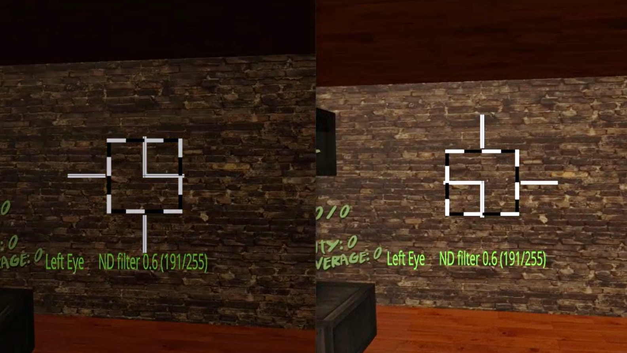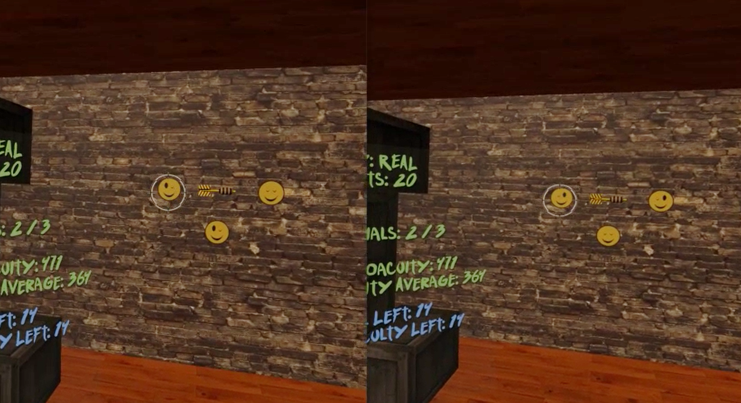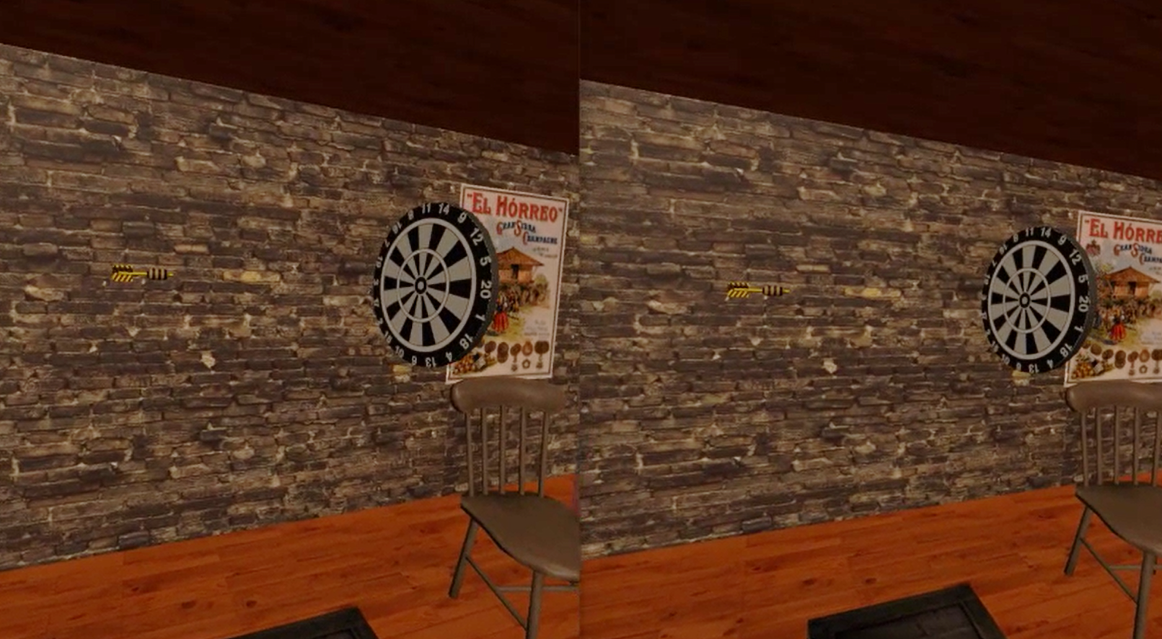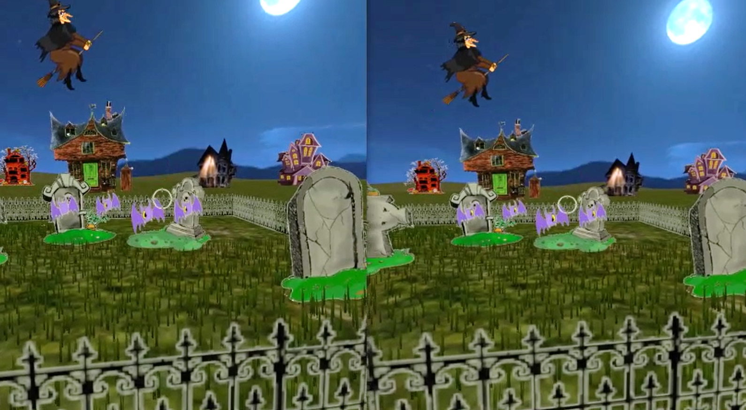

Figure 2. DartBoard and Halloween game screenshots. Top left: Fusion-lock frame calibration for DartBoard (same for Halloween, except the background) to eliminate subjective misalignment angles. Top right: DartBoard 3-AFC suppression test. Bottom left: Example of DartBoard trial. Bottom right: Example of Halloween trial.

Cue scaffolding was implemented in both games, creating three consecutive cues scaffolding conditions (Condition 1, 2, and 3), which progressively eliminate non-stereoscopic depth cues, from an up-to-date VR scene (where accommodation is the only depth cue not simulated) to a scene where only retinal disparity was available. Each session began with Condition 1, which consisted of monocular and binocular cues to depth including shadows, perspective, motion parallax, and binocular disparity. In Condition 2, shadows were eliminated and perspective reduced- meaning, relative size was no longer a reliable cue (i.e., object size was not relative to object distance). Lastly, in Condition 3, motion parallax was limited (only rotational movements of the head were allowed by the software), making binocular disparity the most helpful (almost unique) cue to calculate distance.

A 3-AFC suppression test (by means of dichoptic images) was also inserted in each games’ mechanics to help participants become aware of suppression episodes. For example, in the DartBoard game, participants were instructed to identify the smiley face in a set of three with both eyes open, which could only be seen if binocular fusion was maintained (Figure 2- Top right). In the Halloween game, participants were instructed to eliminate all targets with both eyes open and avoid targets with one eye, which again could only be achieved if binocular fusion was maintained. Importantly, the purpose of the suppression tests was to bring awareness of suppression to participants who actively suppressed. Suppression test failures were registered in both game result files.

Game mechanics and respective in-game measurements were different in each game. In DartBoard, participants were instructed to launch a dart, which was presented at the center of the screen, towards a dartboard that travelled from the back of the participant and moved towards the background of the scene (Figure 2- Bottom left). Each dart launch constitutes a trial. Movement of the dart once launched, was always linear and traveled from left to right, while movement of the board was linear, but not necessarily at a 90° angle or at the same speed of the dart. Both linear movements occurred in the same plane where the observers’ eyes were. Thus, there was no way of guessing the intersection of both trajectories using monocular cues. The movement of the dart board was designed to stop at intervals in order to facilitate the exercise. The perceptual learning task for the participant was estimating, using the background wall as reference, when the dart (stationary object) and the dart board (object moving in depth) were at the same distance (i.e. accuracy could theoretically be as low as zero arc secs). In Halloween, the participant was instructed to shoot the closest target in a variable set of targets (three to seven phantoms, pumpkins or vampires) as they approached the participant (Figure 2- Bottom right). Each shoot constitutes a trial. Similar to the movement of the dartboard, the approaching targets stopped at intervals to facilitate the exercise. Importantly, relative parallax between the targets were constant, and decreased across trials from 1000” to 400” over time, depending on the participants’ performance. Therefore, the perceptual learning task in Halloween was to determine the relative distance between several objects. It is important to note that DartBoard in-game measurements result in accuracy threshold values for each trial at each cue scaffolding condition; while Halloween in-game measurements result in the proportion of correct responses for each stereo demand at each condition.

**RESULTS**

**Overall in-game performance**

* 1. Dartboard

To assess whether there was a difference in overall game performance across groups (stereo-normal and stereo-anomalous) and conditions (1, 2, and 3), we performed a two-way between-subjects ANOVA on all accuracy measures obtained by each participant on each trial. The analysis shows a significant main effect of group (p < 0.001), main effect of condition (p < 0.001) and an interaction effect (p < 0.001).

This means that there was a difference in game performance between groups and across cue scaffolding conditions.

There was a significant interaction between group and condition on game accuracy *F* (2, 102245) = 165, *p* < 0.001.

Main effect analysis showed that the stereo-normal group achieved a lower threshold (Mean = 235” ± 164”) than the stereo-anomalous group (Mean = 291” ± 220”, *p* < 0.001) and performance scaled with condition (*p* < 0.001).

~~All participants showed an improvement in game performance as measured by the pre to post ratio (Figure 2).~~

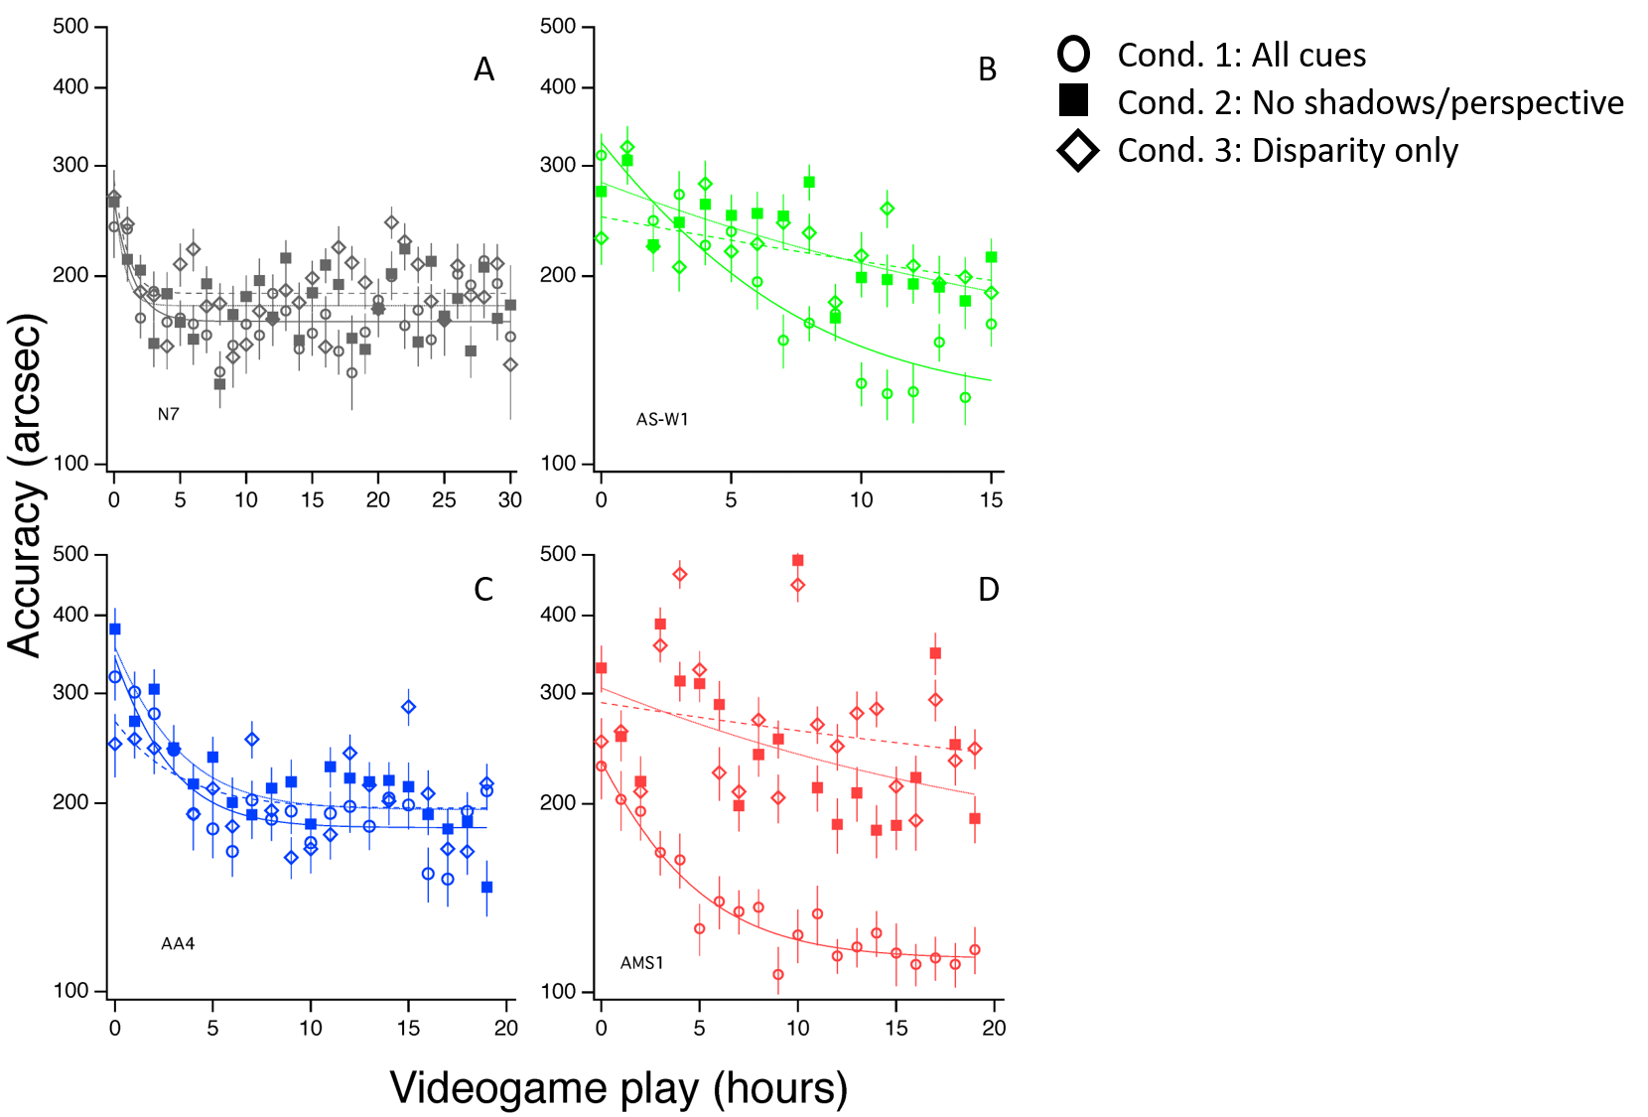

Figure 3. Examples of DartBoard game accuracy for four participants, one stereo-normal (figure 3-A, participant N7) and three stereo-anomalous: figure 3-B, stereo-weak participant AS-W1; figure 3-C, anisometropic participant AA4; and figure 3-D, strabismic participant AMS1. Condition 1 is represented hollow circles, Condition 2 as solid squares and Condition 3 as hollow diamonds.

To assess the amount and rate of learning, we fit game accuracy results for each participant and condition with a three-parameter exponential function (Equation 1). From the fit, we calculated the asymptotic threshold, time constant, and the ratio of baseline to asymptotic threshold (PPR). The asymptotic threshold represents the best performance achieved through training. The time constant represents the time it took for the exponential to fall 37% (1/e) of the starting value. Thus, it represents the rate of learning. Lastly, the PPR represents the amount of learning as a factor of the starting threshold (higher PPR indicates greater learning).

Equation 1. $\left(PPR×e^{-\frac{\# of sessions}{Time constant}}+1\right)×asymptotic threshold$

We performed a two-way between-subjects ANOVA on the PPR to assess whether there was an effect of group or condition on the amount of in-game learning (Figure 4A). We found no significant effect of group *F*(1, 54) = 0.46, *p* = 0.5 or condition *F*(2, 54) = 1.19, *p* = 0.31 on PPT.

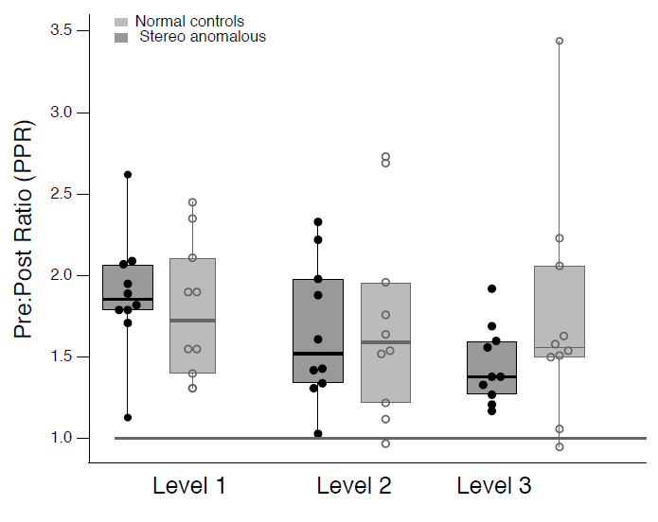

Figure 4A. Effect of group (stereo-normal vs stereo-anomalous) and condition (1, 2 or 3) on pre-post ratio PPR for Dartboard game. Circles represent the PPR of a single participant at each condition. The horizontal line inside the box indicates the group median while the top and bottom lines represent interquartile ranges.

A two-way between-subjects ANOVA on the asymptotic threshold (Figure 4B) showed a significant effect of group *F*(1, 54) = 3.88, *p* = 0.05, with the stereo-normal group reaching a lower threshold on average (Mean = 168.48, SEM = 6.74) compared to the stereo-anomalous group (Mean = 192.15, SEM = 14.26). There was no significant effect of condition on asymptotic threshold *F*(2, 54) = 1.05, *p* = 0.36.

Finally, a two-way between-subjects ANOVA on the time constant showed a non-significant effect of group *F*(1, 54) = 1.06, *p* = 0.31 and a non-significant effect of difficulty *F*(2, 54) = 1.03, *p* = 0.36 on the time it took to reach the asymptote. Meaning, there was no significant difference in the rate of learning between groups and across conditions.



Figure 4B. Effect of group (stereo-normal vs stereo-anomalous) and condition (1, 2 or 3) on DartBoard game accuracy asymptotic threshold. Circles represent the asymptotic threshold of a single participant at each condition. The horizontal line inside the box indicates the group median while the top and bottom lines represent interquartile ranges.

As explained before, a 3-AFC suppression test was presented at the beginning of each trial. The task was designed to ensure that participants were not suppressing. Since there are three possible stimuli to choose from, we established three as the maximum number of dichoptic errors that could be made per trial. Anything above indicates a failure to do the task and is assigned a value of three. To assess the if participants made fewer errors at the end of the study compared to the beginning, we calculated the error ratio by taking the sum of all errors for one participant across the three conditions and dividing by the number of trials. We then, took the average of the first 4 sessions (4 hours of game play) and divided it by the average of the last 4 sessions. We found a moderate correlation of error ratio to PPR in the positive direction (give the r and p values) , indicating that participants who showed a greater ratio (made less errors at the end compared to the beginning) also showed a greater learning ratio (had a greater performance improvement in the game).

QUIVER

We finally compare the improvement of each participant in Condition 1, where all depth cues are available, vs Condition 3, where only retinal disparity is available (Figure 5). For this analysis, we use the exponential function fitting previously explained. Each participant is represented as an arrow, whose start point is the initial accuracy threshold, whose horizontal length the improvement in their use of all depth cues when available(game accuracy threshold Condition 1), and whose vertical length is the improvement in their use of retinal disparity alone (in-game accuracy threshold Condition 3). All arrows point towards a game accuracy limit threshold that seems to be common for both conditions (lower than 200 arc secs). Stereo-normal participant’s arrows point to that threshold, independently if their start point is below or above the 45 degrees line. Nevertheless, stereo-anomalous participants are represented by an arrow that always shows an angle of improvement lower than 45 degrees, i.e. the improvement attributable to the use of retinal disparity is lower than the improvement attributable to the use of all depth cues together.

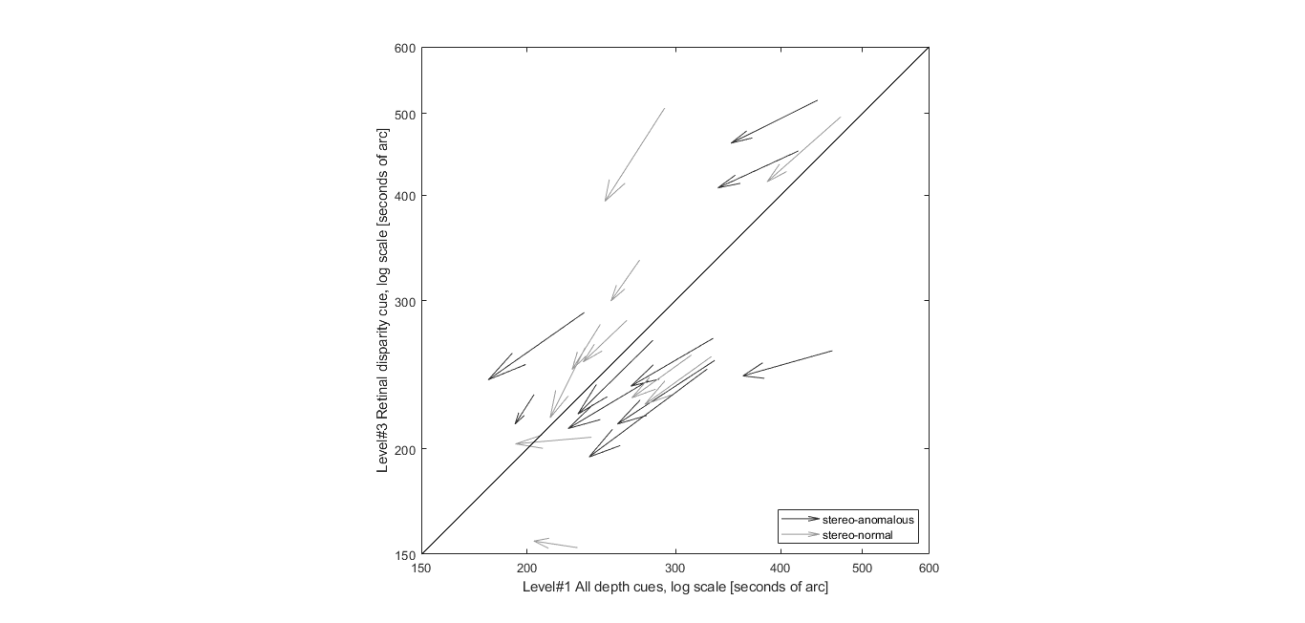

Figure 5. DratBoard game accuracy thresholds in Condition 1 vs Condition 3. Each participant is represented as an arrow, whose start point is the initial accuracy threshold, whose horizontal length the improvement in game accuracy (Condition 1), and whose vertical length is the improvement in game accuracy (Condition 3).

1.2 Halloween

DESCRIBE WHAT IN-GAME STEROACUITY PERFORMANCE MEANS FOR HALLOWEEN

[Introduce figure 6]

As previously explained, Halloween in-game measurements result in the proportion of correct responses for each stereo demand at each Condition on each session. Stereo demand takes the values 1000, 800, 600, and 400 arc seconds. In order to measure improvements, we compare the proportion of right answers of the first 4 sessions (4 hours of game play) vs the last 4 sessions, for each participant at each Condition. Those results are grouped, taking the mean values, into stereo-normal and stereo-anomalous, i.e. anisometropic, strabismic and stereo-weak (Figure 6). Values above the 45 degrees line indicate an improvement in terms of error reduction.

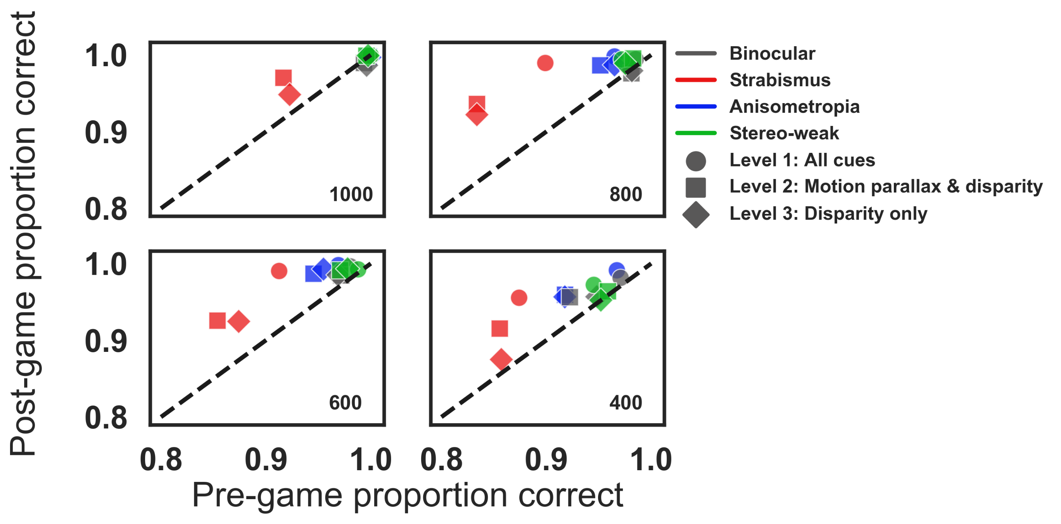

Figure 6. Halloween pre to post proportion correct for disparity values of 1000, 800, 600, and 400 arc seconds. Each symbol represents a different condition for participants with anisometropia (blue), strabismus (red), stereo-weak (green), and normal binocular (grey). Points above the unity line indicate a reduction of errors in the last six blocks compared to the first six blocks.

**Changes in stereoacuity**

2.1. Transfer to clinical measures of stereoacuity: Randot Circles Stereotest® and Random Dot 3 Stereo Acuity Test with Lea Symbols®

All participants in the stereo-anomalous group (except AMS1) showed an improvement in the Randot Circles Stereotest after training (Mean = 167” ± 266”) (Figure 7, solid symbols). Notably, participant AS4 failed the Randot Circles before training and improved by 860”. Only participant AMS1 showed no transfer visual of stereoacuity in the Randot Circles with a consistent measurement of 70” before and after training.

Seven out of the ten stereo-anomalous participants showed an improvement in the Random Dot 3 Stereo Acuity Test (Mean = 251” ± 433”) (Figure 7, open symbols). Three of the ten participants in the stereo-anomalous group (AS1, AS2, and AS4) failed the Randot Dot 3 test before training, but only AS4 improved after training (improved by 1400”), while AS1 and AS2 failed the Random Dot 3 before and after training. Stereo threshold for participant AMS1 was at 400” before and after training.

All participants in the stereo-normal group were at ceiling for both the Randot Cirles (20”) and the Random Dot 3 (12.5”) before training and remained at ceiling after training. Thus, their data is not shown in Figure 7 since it would fall on the unity line.

All four participants with anisometropia showed an improvement in Randot Circles (Mean = 138” ± 162”) and Random Dot 3 (Mean = 264” ± 158”). Comparatively, all four participants with strabismus showed an improvement in Randot Cirles (Mean = 260” ± 402”), but only two (AS3 and AS4) showed an improvement in Random Dot 3 (Mean = 360” ± 963”). The stereo-anomalous participant classified as micro-strabismic (AMS1) did not show an improvement in Randot Circles or Random Dot 3 after training, while the stereo-weak participant (AS-W1) improved by 80” in Randot Circles and 12.5” in Random Dot 3.

To assess whether the initial stereo threshold gives an indication of future improvement, we calculated

Figure 7. Clinical stereoacuity improvement as a function of initial Randot Circles Stereotest® and Random Dot 3 Stereo Acuity Test with Lea Symbols®. Each symbol represents data from one participant in the stereo-anomalous group. Color indicates binocular condition: anisometropia (blue), strabismus (red), or weak stereo (green). (A) Shows a pre- versus post-training plot for Randot (solid symbols) and Random Dot 3 (open symbols) stereoacuity measures. Data under the diagonal unity line indicate an improvement in stereoacuity. (B) Shows the relationship between the initial stereo threshold and the pre to post stereo ratio. Data above the horizontal line indicate an improvement in stereo PPR.

A.

B.

stereo PPR by taking the initial stereo threshold and dividing it by the post stereo threshold (Figure 7B). Overall, participants with a higher (worse) initial stereo threshold as measured with Randot Circles show a higher stereo PPR, meaning they improved more after training.

Participants were measured with the Randot Circles and Random Dot 3 stereo tests at least five times with the exception of AS1, AA1, N5, N8, N10, and N11 who were measured seven times and N2 and N4 who only completed half of the study and were measured three times. Testing every ten hours allowed us to track clinical stereoacuity changes as a function of training hours.

A Wilcoxon Signed-Ranks Test indicated that post clinical stereoacuity measures were lower after training compared to stereoacuity measures before training (Z = 0.0, *p* = 0.00043). (Figure 4). Participants with anisometropia reached a lower threshold (Randot mean = 138” ± 162”; Random Dot 3 mean = 264” ± 158”) at a faster rate (time constant) compared to participants with strabismus (Randot mean = 260” ± 402”; Random Dot 3 = 360” ± 963”, time constant).

To normalize stereo threshold across participants, we took each measured stereo threshold and divided by the highest score possible (20” for Randot and 12.5” for Random Dot 3). We then fit the data, collapsing across stereo tests, with an exponential fit (Equation 2) where y0, A, and tau are fit coefficients.

Equation 2.

~~Participants with anisometropia show greater learning at a higher rate than participants with strabismus and weak-stereo (Figure 9)~~.

2.2. Psychophysical measures of stereoacuity: Pure Disparity Test (PDT) and dynamic random-dot stereogram (DRS)

All participants in the stereo-anomalous group, except for AA3 and AS2, showed an improvement in PDT (Mean = 169” ± 153”) (Figure 10). Participant AA3 and AS2 performed slightly worse after training compared to the initial PDT measurement by 7” and 67” respectively. Participants with strabismus showed a greater improvement (Mean = 193” ± 237”) compared to participants with anisometropia (Mean = 36” ± 51”). All participants in the stereo-normal group, except for N1, N10 and N11, showed an improvement in PDT (Mean = 16” ± 13”). The improvement was smaller compared to the stereo-anomalous group since most stereo-normal participants were close to celling.

The stereo-anomalous group had a greater improvement in RDS small (Mean = 395” ± 717”), medium (Mean = 160” ± 336”), and big (Mean = 539” ± 1255”) compared to the stereo-normal group who were close to celling at the beginning of training and showed only a small improvement (Mean = small: 4” ± 6”; medium: 2” ± 4”; big: 7” ± 11”). RDS improvement in the stereo-anomalous group was largely driven by participants with strabismus (Mean = small: 428” ± 477”; medium: 387” ± 472”; big: 1127” ± 1946”) compared to participants with anisometropia (Mean = small: 14” ± 17”; medium: 13” ± 13”; big: 215” ± 383”).



A.

B.

Figure 7. Psychophysical stereoacuity improvement as a function of initial stereo threshold. Each symbol represents a psychophysical test: PDT (triangle), RDS small (small circle), RDS medium (medium circle) and RDS big (big circle). Colors indicate binocular condition: anisometropia (blue), strabismus (red), stereo-weak (green), and normal stereo (grey). (A) Shows a pre- versus post-training plot. Data under the diagonal unity line indicate an improvement in stereoacuity. (B) Shows the relationship between initial stereo threshold and the amount of stereo improvement. Data above the horizontal line indicates an improvement in stereo.

Psychophysical tests were administered before, after every ten hours, and after the training. Thus, we were able to track psychophysical stereoacuity changes as a function of training hours. Similar to clinical measures of stereoacuity, Wilcoxon Signed-Rank Test indicated that post psychophysical stereoacuity measures were significantly different from stereoacuity measures before training (pre-test mean: ; post-test mean: ; Z = 39, *p* < 0001). Participants with anisometropia reached a lower threshold at a faster rate (time constant) compared to participants with strabismus (time constant).

We normalized psychophysical stereoacuity by dividing each measurement by the highest score possible. We then fit the data, collapsing across stereo tests, with an exponential fit (Equation 2). Similar to the clinical stereoacuity results, participants with anisometropia reached a lower threshold at a faster rate for RDS (Figure 11A) and PDT (Figure 11B).

2.3. Changes in visual acuity

2.4. Changes in suppression

**Discussion.**

**FIRST SECTION**

* In summary, our preliminary results show that most of the stereo deficient players improved in the game and showed transfer to both clinical and psychophysical tests. By its own these results confirm the viability of recovering stereoacuity by means of videogames, as previous studies have stated before [ref2, 4, 5, 6]., despite the different design and nature of the activities used in this work.

[ref0] Portela et al. A Random Dot Computer Video Game Improves Stereopsis. Optom Vis Sci 2018; Vol 95(6)

* Anisometropic participants showed improvements in both clinical tests, whereas all strabismic participants showed improvements Random Dot 3 and all but two in Randot Circles.
* Participants with anisometropia statistically reached a lower threshold at a faster rate compared to participants with strabismus according to both clinical and psychophysical tests.
* Although these results have to be analyzed taking into account the small sample size of our study, they are coherent with previously reported results.
* Anisometropic patients retain stereoacuity at low frequencies [ref1]. Although their stereoacuity is not as acute as normal, it is nevertheless functional. Thereby, anisometric patients are more likely to recover stereoacuity after a PL treatment.
* On the other hand, stereoacuity is more impaired by strabismus than by anisometropia [ref2]. Suppression scotoma may be different, active to avoid diplopia instead of passible due to the visual loss in anisometropia. Strabismus is more refractive to stereoacuity treatments.
* Participants with a higher (worse) initial stereo threshold show a higher stereo PPR, meaning they improved more after training
* The participant classified as micro strabismic (AMS1) did not show improvements in any of both tests.
* This may be explained because microtropia causes usually with harmonious anomalous correspondence [ref3]. Neural binocular connections are present but are not as acute as in normal correspondence. PL learning cannot go beyond that neural limitation, unless anomalous correspondence is treated before.

[ref1] Levi DM, McKee SP, Movshon JA. Visual deficits in anisometropia. Vision Res. 2011; 51: 405 48-57.

[ref2] Levi DM, Knill DC, Bavelier D. Stereopsis and amblyopia: A Mini-review. Vision Res. 385 2015; 114: 17-30.

[ref3] Lang J. Microtropia. Int Ophthalmol. 1983 Jan; 6(1):33-6.

* Seven up to ten participants in the stereo-normal group show improvements in the PDT psychophysical test. Those improvements were not detected by the clinical tests because stereo-normal participants were at ceiling before the treatment.
* Previous research have pointed out improvements in stereoacuity functions after training [6]. Certain professions as dressmakers, where specific stereo demanding tasks are common, show enhanced stereoacuity [7]. There is a reasonable doubt about what the reason is, if good stereoacuity is a condition that has to fulfill the candidate to dressmaker or if the dressmaker enhances its skill due to those stereo demanding tasks. Our result points out that stereoacuity can be improved even when baseline conditions are normal-vision.
* We have not detected transfer to visual acuity in the participants.
* Improvements in stereoacuity after training are not necessarily transferred to visual acuity according to previous studies [ref4, 5, 6].
* Anyway, current state of the art VR headsets have a lack of resolution that makes them not the best tool to train visual acuity.

[ref4] Ding J, Levi DM. Recovery of Stereopsis through Perceptual Learning in Human Adults with Abnormal Binocular Vision. Proc Natl Acad Sci U S A 2011;108:E733–41.

[ref5] Xi J, Jia W, Feng L, et al. Perceptual Learning Improves Stereoacuity in Amblyopia. Invest Ophthalmol Vis Sci 2014;55:2384–91.

[ref6] Vedamurthy et al. Recovering stereo vision by squashing virtual bugs in a virtual reality environment. Philos Trans R Soc Lond B Biol Sci. 2016 Jun 19;371(1697)

* We have not detected neither transfer to a lower visual angle deviation in the strabismic participants.
* Both games require the participant to diverge (Dartboard) or converge (Halloween) to moving targets. There is high scientific evidence of the success of training convergence insufficiency [ref7]. The small sample in our study may justify the inconclusive results regarding effects on deviation angles.

[ref7] Randomized clinical trial of treatments for symptomatic convergence insufficiency in children. Archives of Ophthalmology. 2008 Oct;126(10):1336-49

* We have not measured binocular imbalance in this study. It would be worth to implement in the future a binocular imbalance test in the same VR device. Anti-suppression therapy by means of dichoptic games has little or no effects in stereoacuity according to previous studies [ref8,9,10]

[ref8] Holmes JM, Manh VM, Lazar EL, et al. Effect of a Binocular iPad Game vs Part-time Patching in Children Aged 5 to 12 Years with Amblyopia: A Randomized Clinical Trial. JAMA Ophthalmol 2016;134:1391–400.

[ref9] Kelly KR, Jost RM, Wang YZ, et al. Improved Binocular Outcomes following Binocular Treatment for Childhood Amblyopia. Invest Ophthalmol Vis Sci 2018;59:1221–8.

[ref10] Webber AL, Wood JM, Thompson B. Fine Motor Skills of Children with Amblyopia Improve following Binocular Treatment. Invest Ophthalmol Vis Sci 2016;57:4713–20.

SECOND SECTION

b)      Do in-game results provide a valid result as stereoacuity test despite gammification?

a.      In-game results provide PPR, final stereo-threshold and learning rate at each difficulty condition.

b.      Yes, in-game results in Condition 3 particularly show patient’s improvement in stereoacuity, coherent with clinical and psychological tests

c.       Yes, in-game results in Condition 3 also show differences between stereo-normal, stereo-anomalous and anisometropia vs strabismus, coherent with clinical and psychological tests.

d.      Weakness. Tendencies are detected but values are different. We measure coarse stereoacuity only and in particular conditions, nothing to do with a classic stereo test. The game combines absolute and relative disparity judgement.

e.      Weakness. Halloween in-game results are not as good as Dartboard for this purpose. How can it be improved in the future?

c)      Do conditions really reflect different uses of depth cues for depth perception?

a.      Yes, different conditions are linked to different in-game results. Condition 3 is associated with poorer results

d)      Do different patients learn following the same process?

a.      No, clinical and psychological stereoacuity results show differences between groups regarding stereoacuity outcomes as said before

b.      Most stereo-normal have a better baseline when all cues are present than when stereoacuity is the only available cue. It does not happen the same with the stereo-anomalous, each patient is different.

c.       Stereo-normal improvement is more intense in stereoacuity alone than in all cues integration. Stereo-anomalous improvement is more intense in all cues integration than in stereoacuity alone.

In summary, our preliminary results show that most of the stereo deficient players improved in the game, and several showed transfer to both clinical (Randot®) and dynamic Random Dot Stereoacuity tests (Ding & Levi, 2011).

VR provides an environment to analyze how we perceive depth, by means of cue scaffolding. PL has demonstrated its utility to improve vision skills. Thanks to gamification, PL boring tasks become more engaging, improves motivation and compliance. But the results obtained through game play, in-game results, are maybe not that accurate.

1. We have demonstrated that our implementation of cue scaffolding is valid. The three different conditionss provided different stereoacuity thresholds.
2. Despite using gamification techniques, in-game results show differences between groups of patients. In addition, those differences are coherent with clinical and psychophysical tests. Nevertheless, stereoacuity ranges are limited by game mechanics.
3. In-game results show improvements and those improvements transfer to both clinical and psychophysical tests. The nature of those improvements can be understood thanks to cue scaffolding.
4. Improve in all conditions (cues integration)
5. Improve in all groups (not only anomalous)
6. Differences of learning: results by condition, speed of learning, initial threshold

**

Do different conditions provide different stereoacuity threshold – independently of

patients or time during treatment -? (is cue scaffolding present or not?)

- Do all groups of patients behave equal regarding stereoacuity initial in-game

threshold? (is the game useful to discriminate groups of patients?)

- Can we see any improvement relative to the initial stereoacuity? (do patients

improve?)

- Do all groups of patients behave equal regarding final stereoacuity? (how the learning

takes place in different types of patients)

- Do all groups of patients behave equal regarding improvement relative to the initial

stereoacuity? (how the learning takes place in different types of patients)

- Do all groups of patients behave equal regarding speed of improvement? (how the

learning takes place in different types of patients)

- Do all groups of patients behave equal regarding improvement in depth perception

(general concept) vs stereoacuity?

**

**Conclussions**

We conclude that consumer VR devices may provide a new tool for the recovery of stereopsis in adults with abnormal binocular vision.

**Table 1**

Participant clinical details.

|  |  |  |  |  |  |  |
| --- | --- | --- | --- | --- | --- | --- |
| SID | Age, Gender | Dx | Visual acuity | Ocular alignment | Refractive error | Fixation |
| AA1** | 24, M | Aniso | OD: 20/16  OS: 20/25 +1 | Far: ortho  Near: 4 EP | OD: +1.25 -1.00 x002  OS: +4.25 -1.50 x170 | Central |
| AA2 | 18, F | Aniso | OD: 20/25 -1  OS: 20/20 +1 | Far: ortho  Near: ortho | OD: +1.25 -1.25 x188  OS: +0.25 -0.25 x009 | (-) EF |
| AA3 | 25, F | Aniso | OD: 20/20 +1  OS: 20/16 | Far: 4 EP  Near: 5 EP | OD: +3.00  OS: plano | Central |
| AA4* | 62, M | Aniso | OD: 20/40 -2  OS: 20/20 -1 | Far: ortho  Near: ortho | OD: +7.75 -2.25 x085 (add 2.25)  OS: +5.25 -1.50 x105 (add 2.25) | Central |
| AMS* | 21, M | Strab | OD: 20/25 -2  OS: 20/50 -2 | Far: ortho  Near: ortho | OD: +5.50 -4.75 x008  OS: +5.75 -5.00 x172 | Central |
| AS1 | 36, F | Strab | OD: 20/20  OS: 20/20 -1 | Far: 4 RET  Near: 4 RET | OD: -0.50 DS  OS: -0.25 DS | Central |
| AS2 | 30, F | Strab | OD: 20/20 -1  OS: 20/20 -1 | Far: 2 LET  Near: 4 LET | OD: +3.25 -1.25 x170  OS: +3.50 -1.25 x010 | 0.5 pd temp OS fixation |
| AS3 | 20, M | Strab | OD: 20/20 -2  OS: 20/20 -1 | Far: trace XP  Near: 6 XP | OD: +0.50 -0.50 x180  OS: plano -1.00 x180 | Central |
| AS4 | 54, M | Strab | OD: 20/25 -1  OS: 20/20 -1 | Far: 14 RET 5 HoT  Near: 6 LET 10HyT | OD: -1.00 -0.75 x160  OS: -1.00 -1.00 x020 | Central |
| ASW1 | 22, F | Normal | OD: 20/20 +1  OS: 20/16 -2 | Far: trace XP  Near: 2 XP | OD: -4.25 -1.00 x180  OS: -4.00 -0.75 x160 | Central |
| N1 | 25, F | Normal | OD: 20/16 -1  OS: 20/16 -1 | Far: ortho  Near: ortho | OD: -3.75 -0.75 x174  OS: -4.25 -0.50 x003 | Central |
| N2 | 26, F | Normal | OD: 20/20  OS: 20/20 | Far: ortho  Near: ortho | OD: -6.25 -0.25 x085  OS: -6.25 -0.25 x085 | Central |
| N3 | 28, M | Normal | OD: 20/20 -2  OS: 20/20 | Far: ortho  Near: ortho | OD: plano  OS: plano | Central |
| N4 | 24, F | Normal | OD: 20/25 +1  OS: 20/25 +2 | Far: ortho  Near: 2XP | OD: plano  OS: plano | Central |
| N5 | 28, F | Normal | OD: 20/20 +2  OS: 20/20 +2 | Far: ortho  Near: ortho | OD: -0.50 -2.25 x107  OS: -0.50 -2.25 x078 | Central |
| N6 | 23, F | Normal | OD: 20/16 -2  OS: 20/16 -1 | Far: trace XP  Near: 3 XP | OD: -3.25  OS: -3 | Central |
| N7 | 23, F | Normal | OD: 20/20 +2  OS: 20/20 | Far: trace XP  Near: 3 XP | OD: +0.25 -1.50 x177  OS: +0.25 -1.25 x176 | Central |
| N8 | 24, F | Normal | OD: 20/20 -1  OS: 20/20 | Far: 2 XP  Near: 6 XP | OD: -5.25  OS: -7.5 | Central |
| N9 | 23, F | Normal | OD: 20/16 -1  OS: 20/16 | Far: ortho  Near: 4 EP | OD: -1.00 DS  OS: -1.00 DS | Central |
| N10 | 24, F | Normal | OD: 20/16  OS: 20/12.5 | Far: ortho  Near: ortho | OD: -1.75 DS  OS: -1.75 DS | Central |

AA = Participants with anisometropia in the stereo-anomalous group; A = Stereo-anomalous participant; AS = Participants with strabismus in the stereo-anomalous group; N = Stereo-normal participants; * = participants who have amblyopia. ** = Participant who was amblyopic at the beginning of the study, but not at the end.

Anisometropia participants in the stereo-anomalous group; AMS = Micro-strabismic participants in the stereo-anomalous group; AS = Strabismic participants in the stereo-anomalous group; ASW = Stereo-weak participants in the stereo-anomalous group. N = Stereo-normal participants.

**References.**

[1] Swanston, M. T., & Wade, N. J. (2001). Visual perception: An introduction. Psychology Pres

[2] Wheatstone, C. , 1838 “Contributions to the physiology of vision—Part the first. On some remarkable, and hitherto unobserved, phenomena of binocular vision” Philosophical Transactions of the Royal Society of London 128 371–394

[3] Dennis M. Levi, Roger W. Li Perceptual learning as a potential treatment for amblyopia: A mini-review. Vision Research 49 (2009) 2535–2549

[4] Jian Dinga and Dennis M. Levia, Recovery of stereopsis through perceptual learning in human adults with abnormal binocular vision, PNAS September 13, 2011 108 (37) E733-E741; <https://doi.org/10.1073/pnas.1105183108>

[5] Portela et al. A Random Dot Computer Video Game Improves Stereopsis, Optom Vis Sci. 2018 Jun;95(6):523-535

[6] Schoemann, Micha Daniel et al. Repetitive dynamic stereo test improved processing time in young athletes, Restorative Neurology and Neuroscience, vol. 35, no. 4, pp. 413-421, 2017

[7] Adrien Chopin, Dennis M. Levi & Daphné Bavelier. Dressmakers show enhanced stereoscopic vision. Scientific Reports volume 7, Article number: 3435 (2017)

[8] Jonathan M. Holmes et al. Effect of a Binocular iPad Game vs Part-time Patching in Children Aged 5 to 12 Years With Amblyopia. A Randomized Clinical Trial. JAMA Ophthalmol. 2016 Dec 1;134(12):1391-1400. doi: 10.1001/jamaophthalmol.2016.4262.

[9] Gordon D. Love et al. High-speed switchable lens enables the development of a volumetric stereoscopic display. 2009 / Vol. 17, No. 18 / OPTICS EXPRESS 15716

This research was supported by grant RO1EY020976 from the National Eye Institute (DML), the University of California Chancellor’s Fellowship (AG), and received mobility aid from the Universidad de Oviedo (SMG).